Student Name : Rakyan Satrya Adhikara

Student ID : 219538135

Mock Exam (SIT111 Algorithms and Computer Systems)

Question 16

1. (Answer is on the *task16_a.py* file)

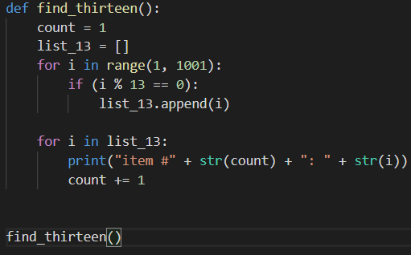

1. (Answer is on the *task16_b.py* file)

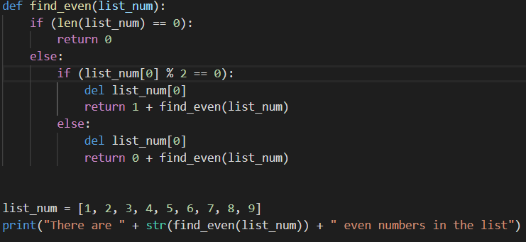

Question 17

1. The algorithmic complexity of the following knapsack algorithm is O(2^n)
2. Since the dynamic programming is reducing the time complexity compared to recursive solution.
3. (Answer is on the *task17_c.py* file)

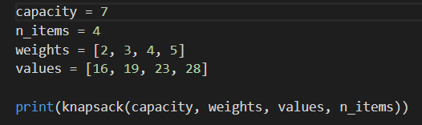

Question 18

1. (Answer is on the *task18_a.py* file)

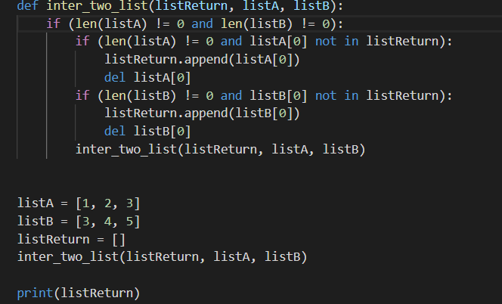

1. Sorts that are perform faster than merge sort can be validated by:
   1. Looking at the time complexity
      1. Meaning if it can perform faster
   2. Looking at the space complexity
      1. Meaning it perform fasts on relative space (preferably more space)

Question 19

1. Internet needs standards since a standard makes it much easier to develop software and hardware that links different networks from different vendors, since software and hardware can be developed one layer at a time.